https://phet.colorado.edu/en/simulation/molecule-shapes
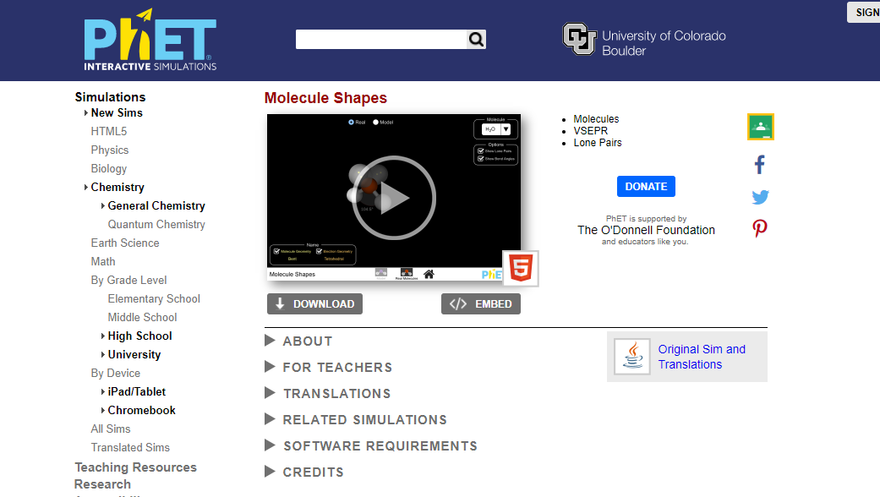

Opening Screen:

“CLICK” this symbol
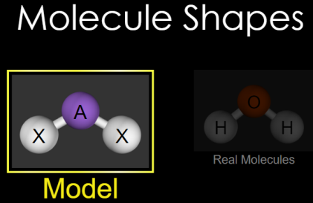
On the next screen, choose MODEL
PhET Molecule Shapes html5

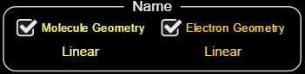
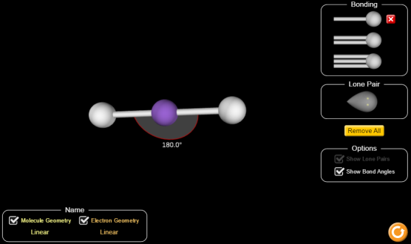
This screen will the appear:

Check the two “Name” tools and the “Show Bond Angles” box.
Play with the sim adding bonds and lone pairs.

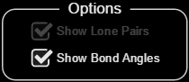
Choose “Show Bond
Angles” if desired.

Explore the impact upon geometries by adding bonds, changing single to double bonds and triple bonds, adding and removing lone pairs of electrons, spinning the molecules, etc. Once a molecule is created, remove any lone electrons to observe what is “seen” when the molecule is magnified.
Spend just a few minutes here, confirming the shapes, bond angles, and geometry names used in class.

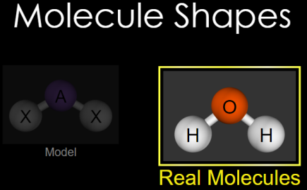
Part 2:
Return to the Main Screen, and choose “Real Molecules”:

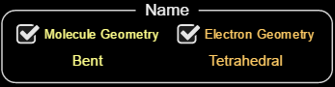
Check boxes:

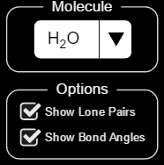
This box allows you to choose between a selection of various molecules. Observe at least five of these molecules, spinning the molecules to better observe the 3-D structure of each and the bond angles.

